Weddings

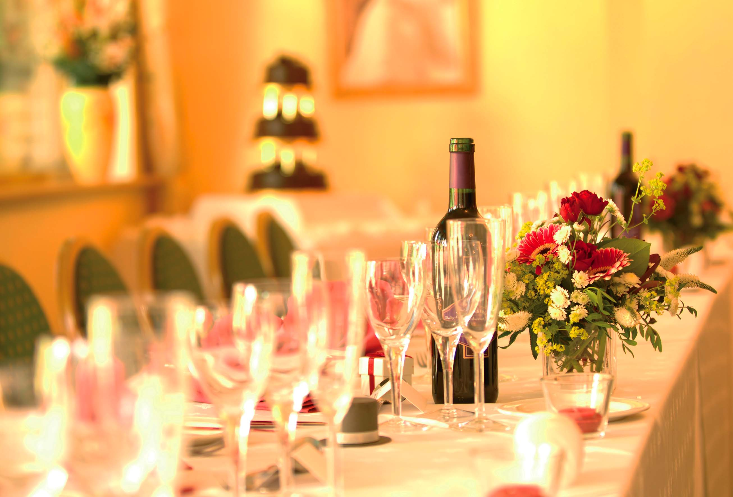

The Shakespeare Hotel
27 Shakespeare Road, Bedford MK40 2DX
Telephone: 01234-213147
www.shakespearehotel.com

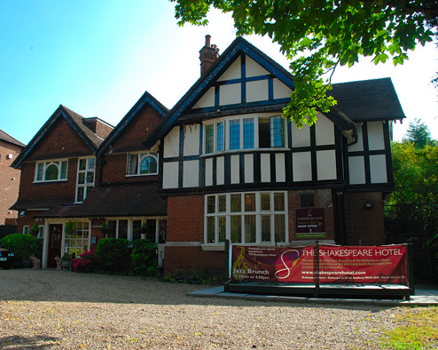

Welcome…

…to The Shakespeare Hotel. We are an independent venue owned and managed by a small close-knit team of professional individuals who are ready and waiting to welcome yourselves and your guests in the celebration of your marriage.

Here the customer is always put first as we strive to not only meet, but also exceed expectations with our aim for all who walk through our front door to leave feeling very much rested and satisfied.

We understand that it is YOUR special day for this reason we tailor our packages to suit your needs.

If you have any questions or queries please do not hesitate to contact us – we are always waiting with a smile and will be more than happy to assist.

Contents

Page
General Information 3
Wedding Packages 4-6
Banqueting menu and buffet choices 7-9
Create Your Own Wedding & Optional Extras 10
Discounted Accommodation for Guests 11
Standard Terms & Conditions 12&13

GENERAL INFORMATION

Ceremonies, Breakfasts & Receptions
We have two suites: Romeo’s & Juliet’s, licensed for wedding ceremonies and with capacity for wedding breakfasts and/or receptions, two fully stocked bars, a patio terrace and secluded walled garden.

Registrar
If you plan to have you wedding ceremony here at The Shakespeare Hotel, you will need to arrange your own registrar and make any associate payments directly with them.

Car Parking
We have an on-site / off road car park located to the front of the hotel with capacity for up to 20 vehicles. In addition there are a number of commercial car parks and on-road car parking areas available within short walking distance.

Accommodations
As well as our dedicated bridal suite, we have twenty en-suite bedrooms covering three floors (including ground level): a variety of single, twin, double and family rooms. There is free WI-FI available throughout the hotel and a full English breakfast is included in all our room rates. As an added bonus, we are happy to offer discounted room rates for your guests see page 20.

Special Dietary Requirements
If you or any of your guests have any special dietary requirements please ask for details as we have a number of menus readily available. Alternatively, our Chef will be more than happy to produce bespoke menus as required.

Younger Guests
If you plan to have any younger guests in attendance we have a limited number of highchairs and travel cots available on a first-book basis (free of charge). For meals you can choose from our Children’s Menus or opt for the same meal as the adults at half portions for half the price.

Event Management
We have a dedicated Functions Coordinator who will be there to guide you as you plan your perfect day so that it is as special and unique as it deserves to be. Remember, this is your wedding and as such if you wish to personalise or amend anything you are more than welcome to.
£999* Wedding Package

N.B. this package is for 35 guests, including the wedding party

Room hire - Juliet’s
Table & chairs
White table cloths & paper napkins (any colour)
Jugs of iced water on each table during meal
Silver cake knife
Sparkling wine & juice for toast
In-house DJ (until midnight)
Bridal suite, for wedding night
Wedding Breakfast
Starters:
- Home-made soup of your choice
- Rosette of dual melon with orange segments (V)
Mains:
- Chicken, Pork or Turkey Roast with all the trimmings & gravy
- Fish cakes and creamy wholegrain mustard sauce with a warm salad & citrus marinade
- Baked aubergine filled with Tuscan vegetables & tomatoes served with sautéed potatoes & a salad garnish (V)
Desserts:
- Warm Belgium waffle served with ice-cream
- Classic profiteroles drizzled with chocolate sauce
- Cheesecake served with cream

Evening Reception
3-Item Buffet, choice of three items from:
- Assorted pizza slices (hot)
- Potato wedges with garlic mayonnaise (hot)
- Mini vegetable spring rolls (hot)
- Selection of filled sandwiches (cold)
- Mini savoury eggs (cold)
- Vegetarian quiche (cold)
- Coleslaw (salad)
- Cous-cous (salad) (V)
- Salad leaves (salad) (V)

Extra Guests: Whole day @ £30.00pp Evening @ £10.00pp

(V) = suitable for vegetarians
PROMOTIONAL OFFER NOT AVALIABLE FOR SATURDAY WEDDINGS

Romeos & Juliet’s Package
- Drinks Reception offering 1 glass per person of House White Wine, House Red Wine, Bucks Fizz or Orange Juice
- 3 Course Meal
- 2 Glasses of Wine served with the meal for the Adults and 2 Glasses of Juice for Children
- Sparkling Wine Toast
- Use of our Silver Cake Knife & Stand
- £1.00 discount per person on evening Buffet
- Discounted accommodation rates for family and friends
- Complementary over night accommodation for Bride & Groom on night of the Wedding including breakfast in Bed
£37.50 per person – min of 50 guest’s

Secret Garden Package
- Drinks Reception offering 1 glass per person of Sparkling Wine, Pimms Bucks Fizz or Orange Juice
- 3 Course Meal
- 2 Glass of Wine served with the meal for the Adults and 2 Glasses of Juice for Children
- Sparkling Wine Toast
- Chair Covers with Tie Backs
- Mirrored Table Centres with Tea Light’s
- Use of our Silver Cake Knife & Stand
- Shakespeare Hotel to make announcements
- £1.00 discount per person on evening Buffet
- Discounted accommodation rates for family and friends
- Complementary over night accommodation for Bride & Groom on night of the Wedding including Champagne breakfast in Bed
£44.95 per person – min of 50 guests

The Shakespeare Special Package
- Drinks Reception offering 1 glass per person of Sparkling Wine, Pimms Bucks Fizz or Orange Juice
- 3 Course Meal
- 2 Glass of Wine served with the meal for the Adults and 2 Glasses of Juice for Children
- Pink Champagne Toast
- Chair Covers with Tie Backs
- Mirrored Table Centres with Tea Light’s
- Use of our Silver Cake Knife & Stand
- Shakespeare Hotel to make announcements
- House DJ
- Discounted accommodation rates for family and friends
- Complementary over night accommodation for Bride & Groom on night of the Wedding including Champagne breakfast in Bed
£59.95 per person – min of 50 guest’s

All packages are inclusive of Juliet's Room Hire.

BANQUETING MENU

Starters

Homemade Soup with Rustic Bread
Chicken Liver Pate, Melba Toast & Chutney
Fan of Melon with Raspberry Coulis
Char-grilled Vegetables and Feta Parcel

Main Course

Slow Roasted Leg of Lamb with Rosemary and a Red Wine Jus
Roast Chicken with Sage & Onion Stuffing
Herb Crusted Fillet of Salmon
Smoked Haddock on a Bed of Wilted Spinach
Roasted Red Onion & Goats Cheese Wellington with Slow Roasted Plum Tomatoes
Wild Mushroom and Leek Risotto Drizzled with Truffle Oil

All served with Roast Potatoes and Seasonal Vegetables

Dessert

Raspberry Crème Brulee served with Shortbread
Glazed Lemon Tart served with Fresh Cream
Classic Profiteroles served with Warm Chocolate Sauce
French Apple Tart served with Vanilla Ice Cream

Followed by Tea, Coffee & Chocolate Mints

Food on Arrival - Canapés

Blinis, vol au vents & vegetable sticks (cold) £3.25

As above plus mini kebabs, skewers & wraps (hot & cold) £4.25

Tortilla chips with dips £2:50

Children’s Banqueting Selector

Starters
Cocktail Sausages with tomato dip
Breaded Cheesy Sticks with tomato dip
Fresh Fruit cut into handy bite-sized pieces (V)

Mains
Chicken breast chunks in a mushroom sauce served with rice
Pasta bake made with turkey mince in a vegetable red sauce
Sausage, mash & beans
Fish fingers, chunky chips & peas
Cheesy omelette with potato wedges

Desserts
Banana Split with ‘squirty’ cream, chocolate sprinkles & vanilla ice cream
Chocolate brownie & ice cream
Jelly and ice cream

Children’s Buffet Selector

Hot Items Cold Items
Chicken Nuggets Selection of Filled Sandwiches
Fish Fingers Sausage Rolls
Assorted Pizza Slices Cheese Rolls
Cheese Dippers Assorted Savouries & Sweet Biscuits
Chunky Chips (V) Tomatoes and Carrot & Cucumber Batons (V)

Buffet Desserts
Jelly & Cream
Mini-Muffins
Fresh Fruit (V)

Evening Buffet
Hot Items
Assorted Pizza Slices
Chicken Satay
Chicken Goujons
Cajun Chicken Drumsticks
BBQ Chicken Wings
BBQ Ribs
Scampi
Fish Goujons & Tartare Sauce
Thai Ginger Fish Kebabs
Mini Vegetable Spring Rolls (V)
Vegetable Samosas (V)
Vegetarian Indian Appetisers & Mango Chutney (V)
Potato Wedges & Garlic Mayonnaise (V)

Cold Items
Selection of Filled Sandwiches
Sausage Rolls
Cheese Rolls
Mini Savoury Eggs
Mini Pork Pies
Chicken Tikka Skewers
Assorted Vol au Vents
Quiche Lorraine
Cheese & Pickled Onion and Cheese & Pineapple Sticks
Smoked Salmon Blinis
Pita Breads with Houmous (V)
Vegetarian Quiche (V)

Salads
Coleslaw
Cheesy Coleslaw
Potato & Chive Salad
Tomato & Mozzarella Salad
Tuna Sweetcorn Pasta
Cous-cous (V)
Oriental Rice Salad (V)
Carrot, Sultanas & Orange (V)
Salad Leaves (V)
Wardorf Salad (V)

Select any SIX items £9.25
Select any NINE items £11.25
Select any ELEVEN items £12.95

Create Your Own Wedding
& Optional Extras

White chair cover £3.50 pp
White chair cover & sash £4.50 pp
White linen napkins £1.00 pp
Coloured linen napkins (choice of colours available) £1.50 pp
Table centre pieces (inc. candles) £1.25 - £5.00 each
Table confetti £0.75 per table
Fresh floral ‘pew-ends’ for ceremony £15.00+ each
Fresh floral bouquets for top table £20.00+ each
Fresh floral centre pieces £5.00+ each
Balloon decorations, cluster of ‘3’ with weight £7.00 each
Balloon decorations, cluster of ‘5’ with weight £10.00 each
Table favours £2.00+ pp
Named place settings £1.00 pp
Chocolate Fountain (2hr maximum run time) £150.00
Other decorations £quotable
In-house DJ (midnight - 01:30) £150.00
Your own DJ/musicians** £75.00
Alternative entertainment £quotable
Two ‘changing rooms’ before ceremony £30.00 each

Drinks
Table Wine: Red, Rose or White £3.50 / glass
Table Wine: Red, Rose or White £12.50 / bottle

**if you choose to arrange your own DJ/musicians who need to plug into our electrical sockets, we require copies of their PAT Certificates for inspection 2-weeks prior to your event

Discounted Accommodation for Guests

Your family and friends are invited to take advantage of these fantastic rates, offered especially to them…

Single £45.00 (usually up to £52.20)

Double / Twin (for single occupancy) £50.00 (usually up to £59.50)

Double / Twin £60.00 (usually up to £69.50)

Family (max. 2 adults & 1 child) £70.00 (usually up to £79.50)

Family (max. 3 adults) £75.00 (usually up to £84.50)

Family (max. 2 adults & 2 children) £80.00 (usually up to £89.50)

Family (max. 4 adults) £90.00 (usually up to £99.50)

…all our rates include full English breakfast cooked to order as well as cereals, toast, yoghurt, fruit, tea, coffee, juice, milk and preserves.

As soon as you have secured your date and paid a deposit your guests are free to book via the hotel direct on 01234 213147.

Please note that whilst we do not limit the number of rooms offered at these discounted rates; the offer is subject to room availability.

Standard Terms & Conditions

- Provisional bookings must be confirmed within 14 days of booking by paying the non-refundable, non-transferable deposit referred to below.
- Deposits paid are non-refundable and non-transferable.
- Final numbers are required no later than 2 weeks prior to your function. If final numbers are less than originally booked then a cancellation charge will apply. If final numbers increase over the previously booked amount charges will apply accordingly.
- The balance of the function cost is payable by the dates set out below.
- If you want to cancel you must notify the hotel in writing and the hotel will be entitled to retain your deposit. Any reduced or waived cancellation costs are only permitted to be authorised by and at the hotel manager’s discretion.
- If the hotel receives your cancellation less than 6 weeks before the function date, the full function cost will remain payable.
- If, due to unforeseen circumstances, the hotel does not have the number and type of rooms available within the hotel on the date(s) required for the function, the hotel reserves the right (without liability) to relocate the function to an alternative hotel of a similar standard in the same locality.
- If a particular room which has been booked is unavailable at the hotel on the required dates, the hotel reserves the right (without liability) to relocate the booking to an alternative room of a similar standard within the same hotel.
- Any reasonable expenses incurred for relocation shall be borne by the hotel. The acceptance of this obligation (which will not release the client of the obligation to pay the hotel the relevant charges) shall be in lieu of all other liabilities or obligations.
- The hotel reserves the right to accept more than one function on a particular day. If you wish to obtain exclusive use of the hotel for your function, this may be arranged for an additional charge.
- Restrictions apply to children and under 18’s at certain functions.
- Card details will be required for all accommodation bookings at the time of booking to secure the room(s). Full payment will then be taken on departure, for accommodations and any associated room charges. The following cards are accepted for payment – Visa, Mastercard, Maestro, Electron and Solo. Payments by American Express will incur a 4% surcharge. Personal cheques are accepted when accompanied by a cheque guarantee card: only one cheque per group booking.
- The hotel reserves the right to amend the price upon written notification to the client in order to reflect any change in cost beyond the reasonable control of the hotel (including but not limited to changes in VAT and import/export duties).
- The client shall make all payments due under the contract in Pounds Sterling within 14 days of the date of the relevant invoice or requested for payment.
- For all functions except weddings: 50% payment is required no less than 8 weeks prior to the function with the final 50% due no less than 2 weeks prior. For wedding bookings: 50% payment is required no less than 12 weeks prior to the wedding date with the final 50% due no less than 4 weeks prior to the wedding.
- Where there is reasonable chance of additional costs being incurred, the client shall provide the hotel with debit/credit card details 14 days prior to the function.
- Invoices shall be sent to the address (postal or e-mail) marked for the attention for the main point of contact (unless otherwise advised). The client shall notify the hotel of any change to the billing address and/or contact details as soon as reasonably practicable.
- A credit account may be applied for up to 28 days prior to the function and, if accepted will be confirmed to the client by the hotel. For the avoidance of doubt, credit accounts are given at the absolute discretion of the hotel manager.
- The hotel reserves the right to amend or withdraw credit facilities at any time and/or require payment of the price or any other amount due in full or in part, without further liability, upon written notice to the client if in the hotel’s view, the client’s credit worthiness deteriorates.
- If the client is an approved credit account customer of the hotel, the client shall pay to the hotel a deposit of 50% of the function cost at least one month prior to the function date and shall pay the remaining balance within 14 days of the date of invoice.
- Bedroom accommodation is available from 2pm on the day of arrival and must be vacated by 11am on the day of departure, unless specific alternative arrangements have been agreed with the hotel. Extension beyond these times shall entitle the hotel to impose additional charges.
- For bookings where accommodation rooms have been placed on hold, any unconfirmed bedroom allocations will be released 4 weeks prior to the function.
- All offers are subject to availability.
- We are always happy to accommodate special dietary requirements providing adequate notice has been given to the hotel prior to your function.
- The hotel reserves the right to change the menus, if necessary without prior notice.
- The hotel reserves the right to move the function to a smaller or larger function suite should numbers dictate.
- All details are correct at the time of going to print but may be subject to alterations without prior notice.
- The management of the hotel reserves the right to refuse entry to the hotel or to remove any persons who behave in a manner that is considered unacceptable to the hotel. In addition, the hotel reserves the right to charge the organiser, company or individual for any damages caused by unreasonable behaviour.
- The hotel reserves the right to refuse any external entertainment, services or activities that the client may have arranged and does not accept any liability for the acts or omissions of any party employed by the client in connection with the function.

continued on next page…

- The client shall (and shall ensure that all third parties employed by the client) comply at all times with all regulations (whether statutory or otherwise), the hotel’s rules and regulations and any reasonable requests of the hotel. The client shall also ensure that these conditions are brought to the attention of all third parties employed in connection with the function.
- The client shall (and shall ensure that all third parties employed by the client) comply with the terms of all licences, consents, permits and conditions; and any decision or recommendation by the licensing officer or other licensing or entertainment authority.
- Unless specific security arrangements are made with the hotel, the hotel accepts no responsibility or liability for any loss or damage to property of the client, delegates/guests or any third parties employed by the client beyond the requirements of the Hotel Proprietors Act 1956 (as may be amended). The client should note that not all function areas are capable of being locked and that the client is responsible for informing delegates/guests and any third parties of this prior to the function and for taking all reasonable security precautions.
- Security can be arranged by the hotel with adequate prior notice at an additional charge.
- The client shall (and shall ensure that all third parties employed by the client) comply at all times with all fire, electrical, health and safety regulations (whether statutory or otherwise) including (but not limited to) the Fire Precautions Act 1971 (as may be amended).
- The client shall ensure that any materials brought into the hotel (e.g. stage sets) are so far as possible made of non-flammable materials, that fire exits are kept clear at all times, and where a fire exit sign will be obscured, the client shall ensure that appropriate temporary signs are erected.
- All electrical contractors must be registered with a recognised authority and the client shall provide the hotel with written evidence of this if requested by the hotel.
- The client shall provide the hotel with a list of names of all visiting contractors or third parties if requested by the hotel.
- The hotel reserves the right to evacuate the hotel in the event of a fire alarm or other emergency irrespective whether it is a genuine emergency or not, in order to protect all guests and staff and in this event, does not accept any liability for any consequential delays to the function.
- The client shall obtain prior written approval from the hotel if there is a requirement to fix items to the walls, floors or ceilings: the hotel reserves the right to refuse permission or to offer an alternative that will be acceptable.
- The use of smoke machines, lasers, fireworks, cracked oil, dry ice or any form of pyrotechnic is not permitted anywhere on the hotel premises.
- The hotel reserves the right to cancel the function under the following circumstances: in the opinion of the hotel there has been a significant change in the contracted booking; the client is insolvent or the hotel has reasonable grounds for believing the same; the hotel is not satisfied with the client’s credit status; in the opinion of the hotel the function might prejudice the reputation of the hotel; if the hotel or any part of it is closed or damaged due to circumstances beyond it’s reasonable control; or the hotel is requested to cancel the function by any government or other authority.
- If the hotel is prevented or hindered from hosting the function by a force majeure event (see definition below) the hotel may, as its sole option, and without being liable for any loss or damage suffered by the client or guests/delegates or of any third party employed by the client re-locate the function to another hotel in the same locality, or terminate the contract forthwith by giving notice to that effect to the client.
- A ‘force majeure event’ refers to any circumstances beyond the control of the hotel including, but not limited to, acts of God, fire, explosion, adverse weather conditions, flood, earthquake, terrorism, riot, civil commotion, war, hostilities, strikes, work stoppages, slow-downs or other industrial disputes, accidents, riots or civil disturbances, acts of government, lack of power and delays by suppliers or materials shortages but, for the avoidance of doubt, nothing shall excuse the client from any payment obligations under the contract.
- The client shall not (and shall ensure that all guests/delegates and third parties employed do not) use the name, logo or any details of the hotel for any matter, or permit external food or beverage to be brought into the hotel without prior written approval from the hotel.
- The client shall not (and shall ensure that all guests/delegates and third parties do not) permit any goods, services or any other applicable items (including, but not limited to, tickets) to be sold within the hotel’s premises without the prior written approval of the hotel and any public authority, where necessary.
- No variation or alteration of any of the contract shall be effective unless it is in writing and signed by or on behalf of the client and the hotel.
- No smoking allowed in the hotel.

